Kathmandu College of Technology
Lokanthali, 16 Bhaktapur


A Lab report of
“Artificial Intelligence, CACS-410”
As required for the partial fulfilment of the
BCA 7th Semester
Affiliated to Tribhuvan University.
Submitted By:  Name: Nayan Khanal  Roll No: 12 | Submitted To:  Rajesh Gautam  Lecturer, BCA
September, 2026

CERTIFICATE FROM THE SUPERVISOR
This is to certify that the Lab Report entitled “Artificial Intelligence” is an academic project work done by “Nayan Khanal” submitted in the partial fulfillment of the requirements for the degree of Bachelor of Computer Application at Faculty of Humanities and Social Science, Tribhuvan University under my counselling and guidance. To the best of my knowledge, the work performed by him in the Lab report is his own origination.

_____________________  Internal Examiner | _____________________  External Examiner
ACKNOWLEDGEMENT
We must take this opportunity to acknowledge our sincere gratitude to the Kathmandu College of Technology for providing this type of quality education in the field of computer application which helps students to broaden the concept of computer and its uses in various fields.
In addition, we would like to give a word of thanks to Mr. Rajesh Gautam and rest of the entire faculty members of Bachelor in Computer Application (BCA) of Kathmandu College of Technology, who encouraged us to perform various computer activities.
THANK YOU!
Lab 1 Qn. 1
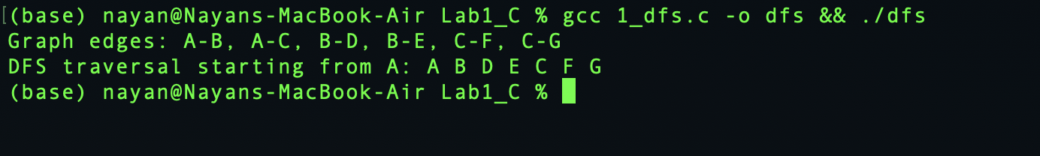
Lab 1 Qn. 2
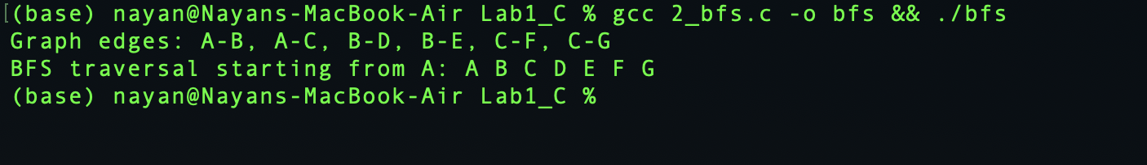
Lab 1 Qn. 3
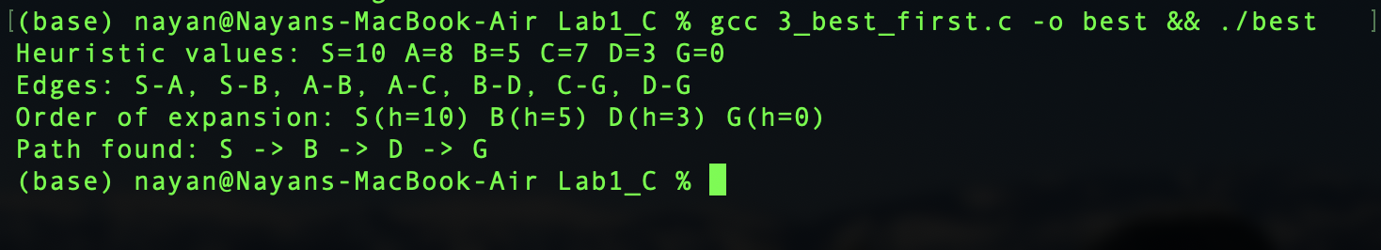
Lab 1 Qn. 4
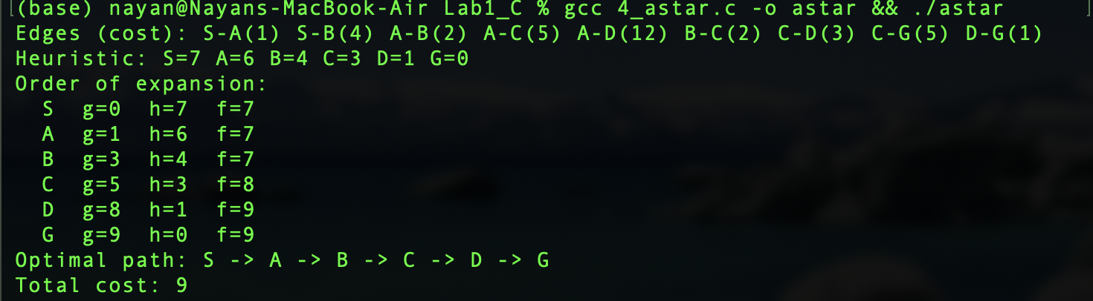
Lab 2 Qn. 1
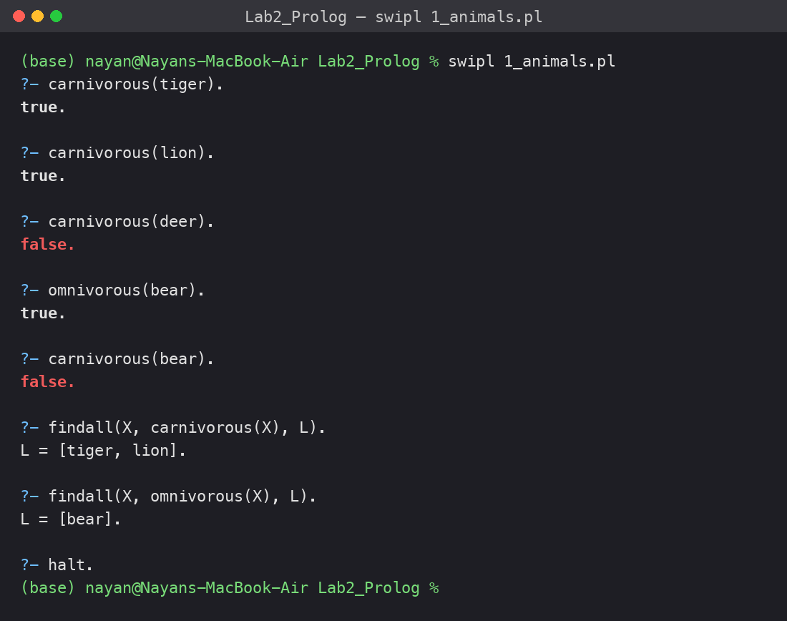
Lab 2 Qn. 2
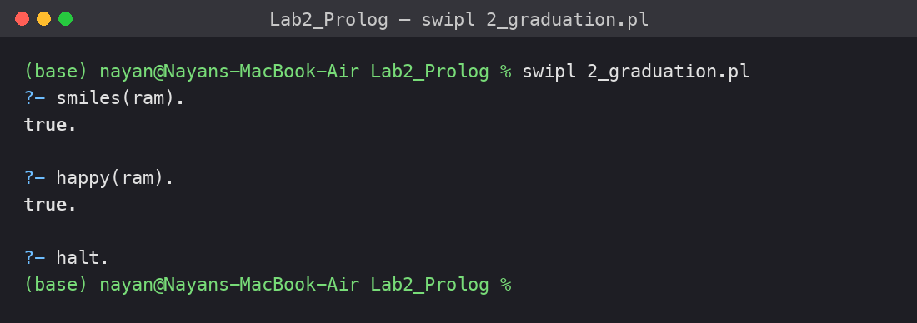
Lab 2 Qn. 3
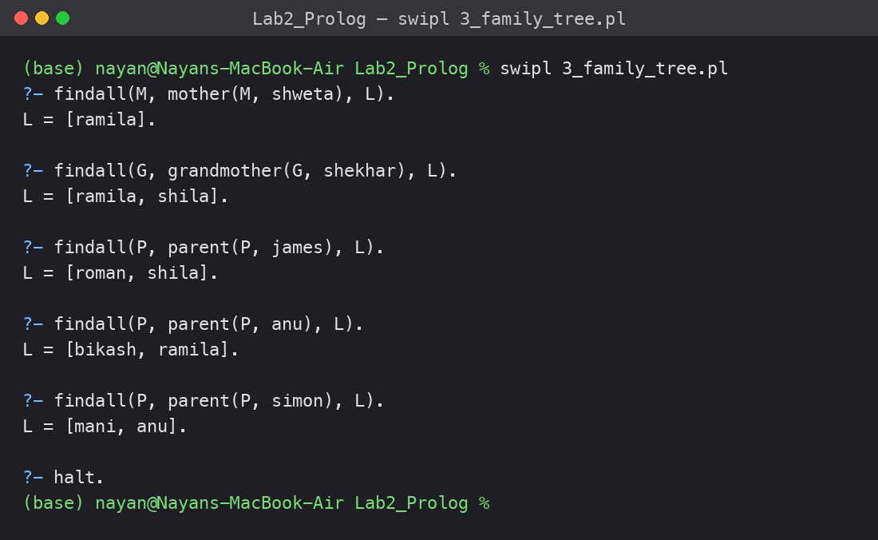
Lab 2 Qn. 4
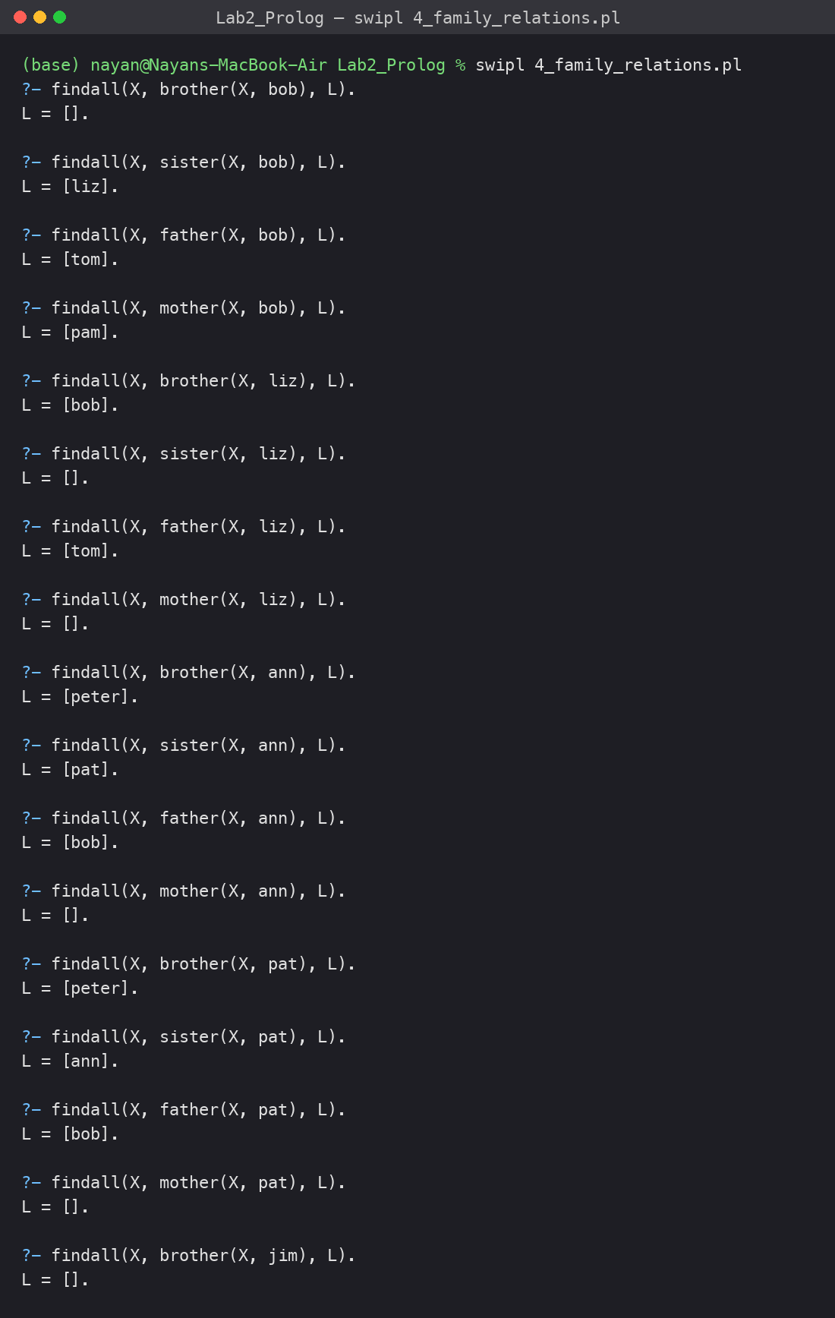

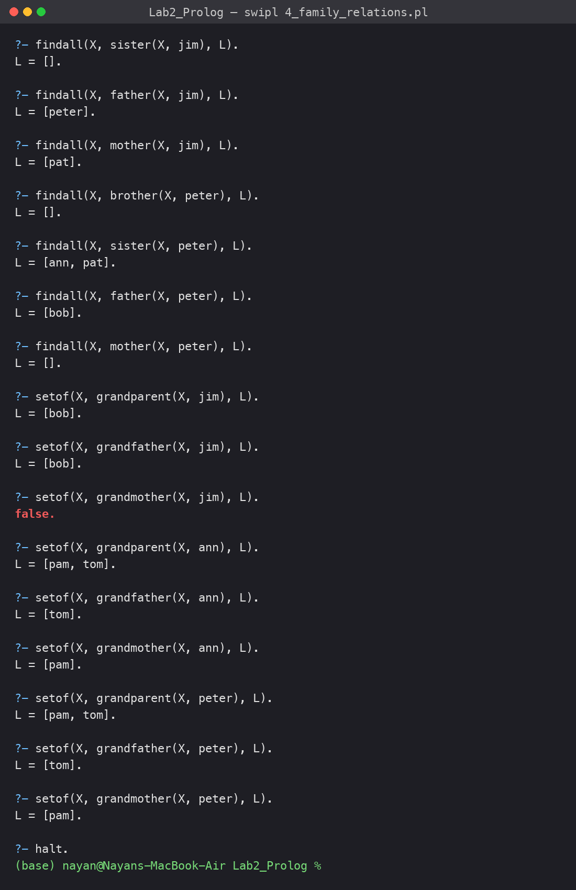
Lab 2 Qn. 5
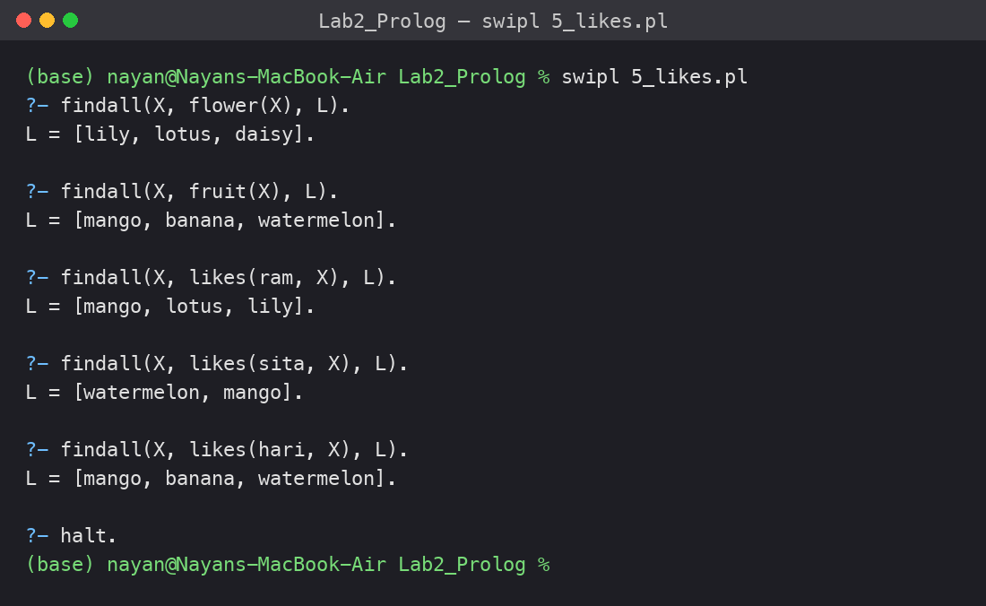
Lab 2 Qn. 6
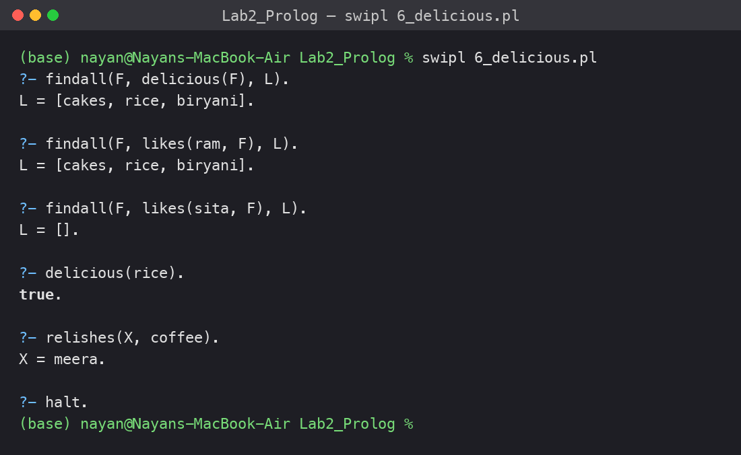
Lab 2 Qn. 7
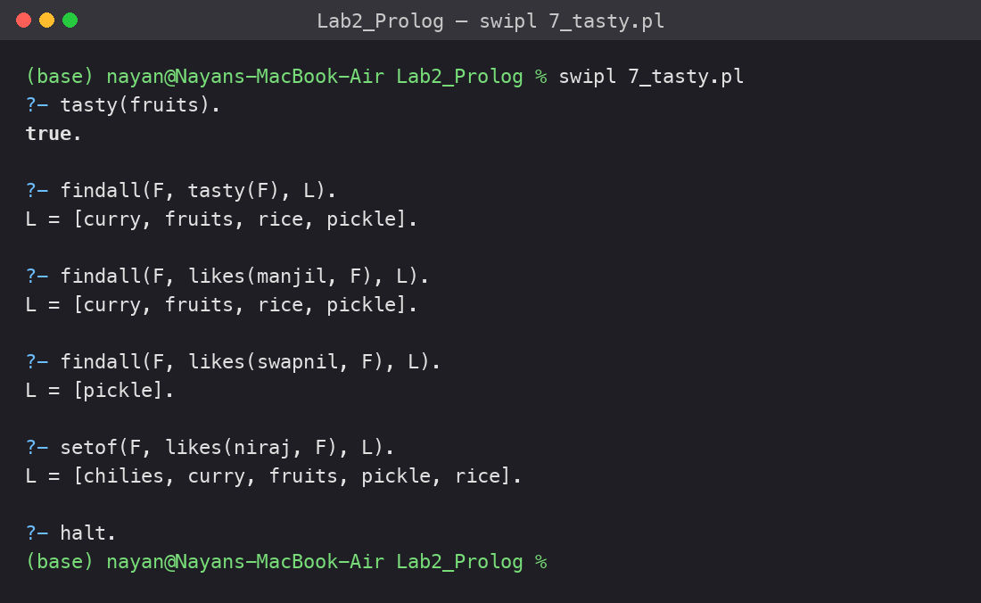
Lab 2 Qn. 8
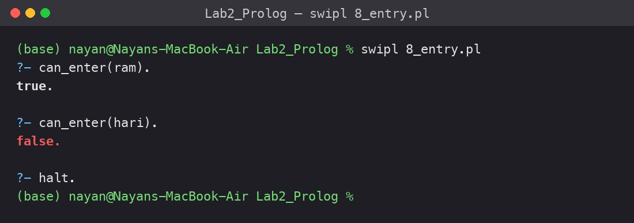
Lab 3 Qn. 1
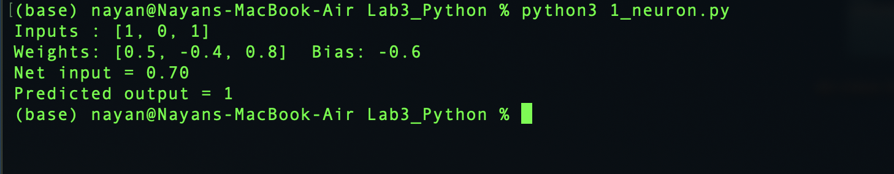
Lab 3 Qn. 2
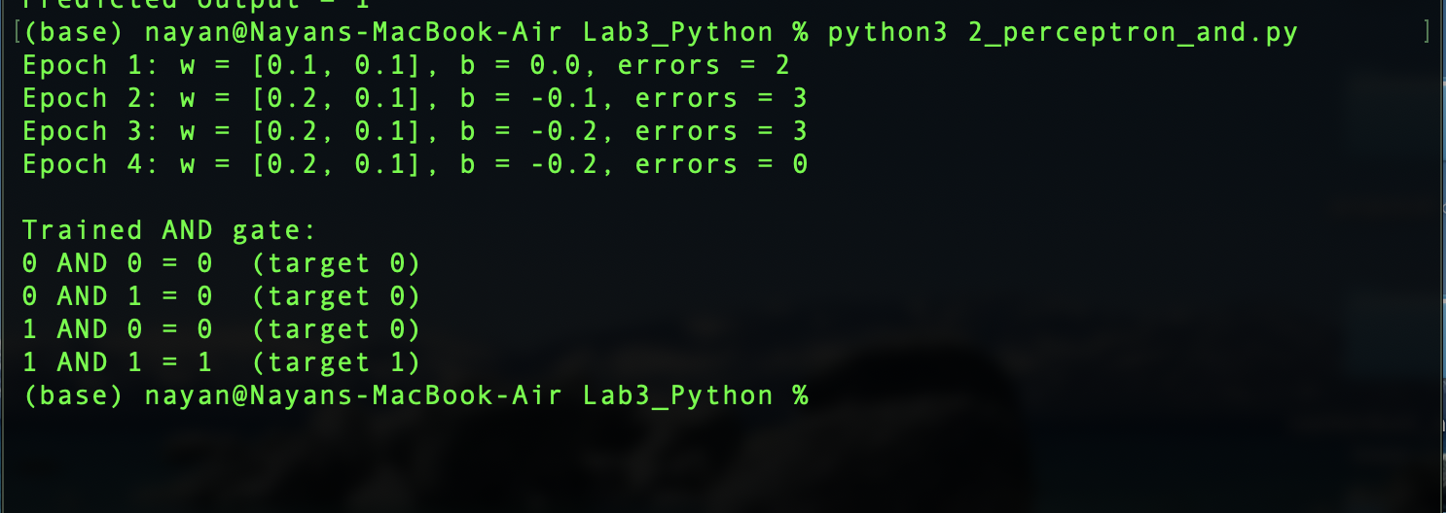
Lab 3 Qn. 3


